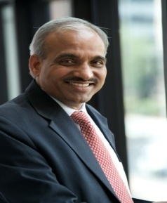

Professor Bhimaraya Metri

